ASSIGNMENT 5
Hotel Room Booking System
Unit 2 – Object-Oriented Programming | Individual Coding Assignment

1. Objective
The objective of this assignment is to develop a menu-driven Java application for managing hotel room bookings. The program demonstrates Object-Oriented Programming through classes and objects, constructors, the this keyword, encapsulation using private data members with getters and setters, static members, methods, Scanner-based input, booking and cancellation operations, room-status checking, and bill calculation.

2. Problem Statement
Develop a Java program that models hotel rooms as objects and allows a user to book a room, display room details, calculate the bill, check booking status, cancel a booking, and view the total number of bookings made. Room prices depend on the selected room type.

3. Room Types and Pricing
Room Type | Price Per Day
Standard | ₹2000
Deluxe | ₹3500
Premium | ₹5000

4. Class Design and Encapsulation
Member / Method | Purpose
roomNumber | Stores the unique room number.
roomType | Stores the room category: Standard, Deluxe, or Premium.
customerName | Stores the customer's name.
numberOfDays | Stores the number of booked days.
pricePerDay | Stores the applicable daily room price.
bookingStatus | Stores whether the room is Booked or Available.
Getters and Setters | Provide controlled access to private fields.
Parameterized Constructor | Initializes a Room object using this keyword.
static totalBookings | Tracks bookings across all Room objects.

5. Menu Operations
1. Book Room
2. Display Room Details
3. Calculate Bill
4. Check Room Status
5. Cancel Booking
6. Display Total Bookings
7. Exit

6. Concepts and Techniques Used
Class and objects for modelling hotel rooms
Parameterized constructor
this keyword
Encapsulation using private data members
Getter and setter methods
Static variable for total bookings
Instance methods for booking, display, bill, status, and cancellation
Scanner for user input
Menu-driven loop and switch statement
Conditional validation for room numbers and booking status

7. Methods Implemented
Method | Function
Room(...) | Parameterized constructor used to initialize a room object.
bookRoom(...) | Sets customer details, number of days, status, and increments total bookings.
displayRoomDetails() | Displays room, customer, pricing, days, and booking status.
calculateBill() | Calculates Number of Days × Price Per Day.
cancelBooking() | Resets booking details and makes the room available.
checkStatus() | Displays whether the room is booked and by whom.
getters / setters | Provide controlled access to private fields.

8. Complete Source Code
import java.util.Scanner;
class Room {
private int roomNumber;
private String roomType;
private String customerName;
private int numberOfDays;
private double pricePerDay;
private String bookingStatus;
private static int totalBookings = 0;
public Room(int roomNumber, String roomType, double pricePerDay) {
this.roomNumber = roomNumber;
this.roomType = roomType;
this.pricePerDay = pricePerDay;
this.customerName = "Not Booked";
this.numberOfDays = 0;
this.bookingStatus = "Available";
}
public int getRoomNumber() { return roomNumber; }
public String getRoomType() { return roomType; }
public String getCustomerName() { return customerName; }
public int getNumberOfDays() { return numberOfDays; }
public double getPricePerDay() { return pricePerDay; }
public String getBookingStatus() { return bookingStatus; }
public void setCustomerName(String customerName) {
this.customerName = customerName;
}
public void setNumberOfDays(int numberOfDays) {
this.numberOfDays = numberOfDays;
}
public void setBookingStatus(String bookingStatus) {
this.bookingStatus = bookingStatus;
}
public void bookRoom(String customerName, int numberOfDays) {
if (bookingStatus.equals("Booked")) {
System.out.println("Room " + roomNumber + " is already booked.");
return;
}
this.customerName = customerName;
this.numberOfDays = numberOfDays;
this.bookingStatus = "Booked";
totalBookings++;
System.out.println();
System.out.println("===== Booking Confirmation =====");
System.out.println("Room Number : " + roomNumber);
System.out.println("Room Type : " + roomType);
System.out.println("Customer Name : " + customerName);
System.out.println("Number of Days: " + numberOfDays);
System.out.println("Price Per Day : ₹" + (int) pricePerDay);
System.out.println("Total Bill : ₹" + (int) calculateBill());
System.out.println("Room booked successfully.");
}
public void displayRoomDetails() {
System.out.println();
System.out.println("===== Room Details =====");
System.out.println("Room Number : " + roomNumber);
System.out.println("Room Type : " + roomType);
System.out.println("Price Per Day : ₹" + (int) pricePerDay);
System.out.println("Customer Name : " + customerName);
System.out.println("Number of Days: " + numberOfDays);
System.out.println("Booking Status: " + bookingStatus);
}
public double calculateBill() {
return numberOfDays * pricePerDay;
}
public void cancelBooking() {
if (!bookingStatus.equals("Booked")) {
System.out.println("Room " + roomNumber + " is not currently booked.");
return;
}
customerName = "Not Booked";
numberOfDays = 0;
bookingStatus = "Available";
System.out.println("Booking for Room " + roomNumber + " has been cancelled.");
}
public void checkStatus() {
System.out.println("Room " + roomNumber + " Status: " + bookingStatus);
if (bookingStatus.equals("Booked")) {
System.out.println("Booked by: " + customerName);
}
}
public static int getTotalBookings() {
return totalBookings;
}
}
public class HotelRoomBookingSystem {
public static Room findRoom(Room[] rooms, int roomNumber) {
for (Room room : rooms) {
if (room.getRoomNumber() == roomNumber) {
return room;
}
}
return null;
}
public static void main(String[] args) {
Scanner scanner = new Scanner(System.in);
Room[] rooms = {
new Room(201, "Standard", 2000),
new Room(202, "Standard", 2000),
new Room(203, "Deluxe", 3500),
new Room(204, "Deluxe", 3500),
new Room(205, "Premium", 5000)
};
while (true) {
System.out.println();
System.out.println("===== Hotel Room Booking System =====");
System.out.println("1. Book Room");
System.out.println("2. Display Room Details");
System.out.println("3. Calculate Bill");
System.out.println("4. Check Room Status");
System.out.println("5. Cancel Booking");
System.out.println("6. Display Total Bookings");
System.out.println("7. Exit");
System.out.print("\nEnter your choice: ");
if (!scanner.hasNextInt()) {
System.out.println("Invalid input. Please enter a number from 1 to 7.");
scanner.next();
continue;
}
int choice = scanner.nextInt();
scanner.nextLine();
if (choice == 7) break;
if (choice >= 1 && choice <= 5) {
System.out.print("Enter room number: ");
if (!scanner.hasNextInt()) {
System.out.println("Invalid room number.");
scanner.next();
continue;
}
int roomNumber = scanner.nextInt();
scanner.nextLine();
Room room = findRoom(rooms, roomNumber);
if (room == null) {
System.out.println("Room not found.");
continue;
}
if (choice == 1) {
System.out.print("Enter customer name: ");
String name = scanner.nextLine();
System.out.print("Enter number of days: ");
int days = scanner.nextInt();
scanner.nextLine();
if (days > 0) room.bookRoom(name, days);
else System.out.println("Number of days must be greater than 0.");
} else if (choice == 2) {
room.displayRoomDetails();
} else if (choice == 3) {
System.out.println("===== Bill Details =====");
System.out.println("Room Number: " + room.getRoomNumber());
System.out.println("Customer Name: " + room.getCustomerName());
System.out.println("Number of Days: " + room.getNumberOfDays());
System.out.println("Price Per Day: ₹" + (int) room.getPricePerDay());
System.out.println("Total Bill: ₹" + (int) room.calculateBill());
} else if (choice == 4) {
room.checkStatus();
} else if (choice == 5) {
room.cancelBooking();
}
} else if (choice == 6) {
System.out.println();
System.out.println("===== Booking Statistics =====");
System.out.println("Total Bookings Made: " + Room.getTotalBookings());
} else {
System.out.println("Invalid menu choice. Please select 1 to 7.");
}
}
System.out.println();
System.out.println("Thank you for using the Hotel Room Booking System.");
System.out.println("Program exited successfully.");
scanner.close();
}
}

9. Calculations and Results
Standard Room Bill = Number of Days × ₹2000
Deluxe Room Bill = Number of Days × ₹3500
Premium Room Bill = Number of Days × ₹5000
Example execution: Premium Room 205 × 5 days = 5 × ₹5000 = ₹25000
The execution shown in the screenshots successfully books Room 205 for Sasanka for 5 days, displays its details, calculates the ₹25000 bill, checks the booked status, reports 1 total booking, cancels the booking, and exits successfully.

10. Program Execution Screenshots
The following screenshots document the program execution in the VS Code terminal, including room booking, room details, bill calculation, status checking, booking statistics, cancellation, and successful program exit.
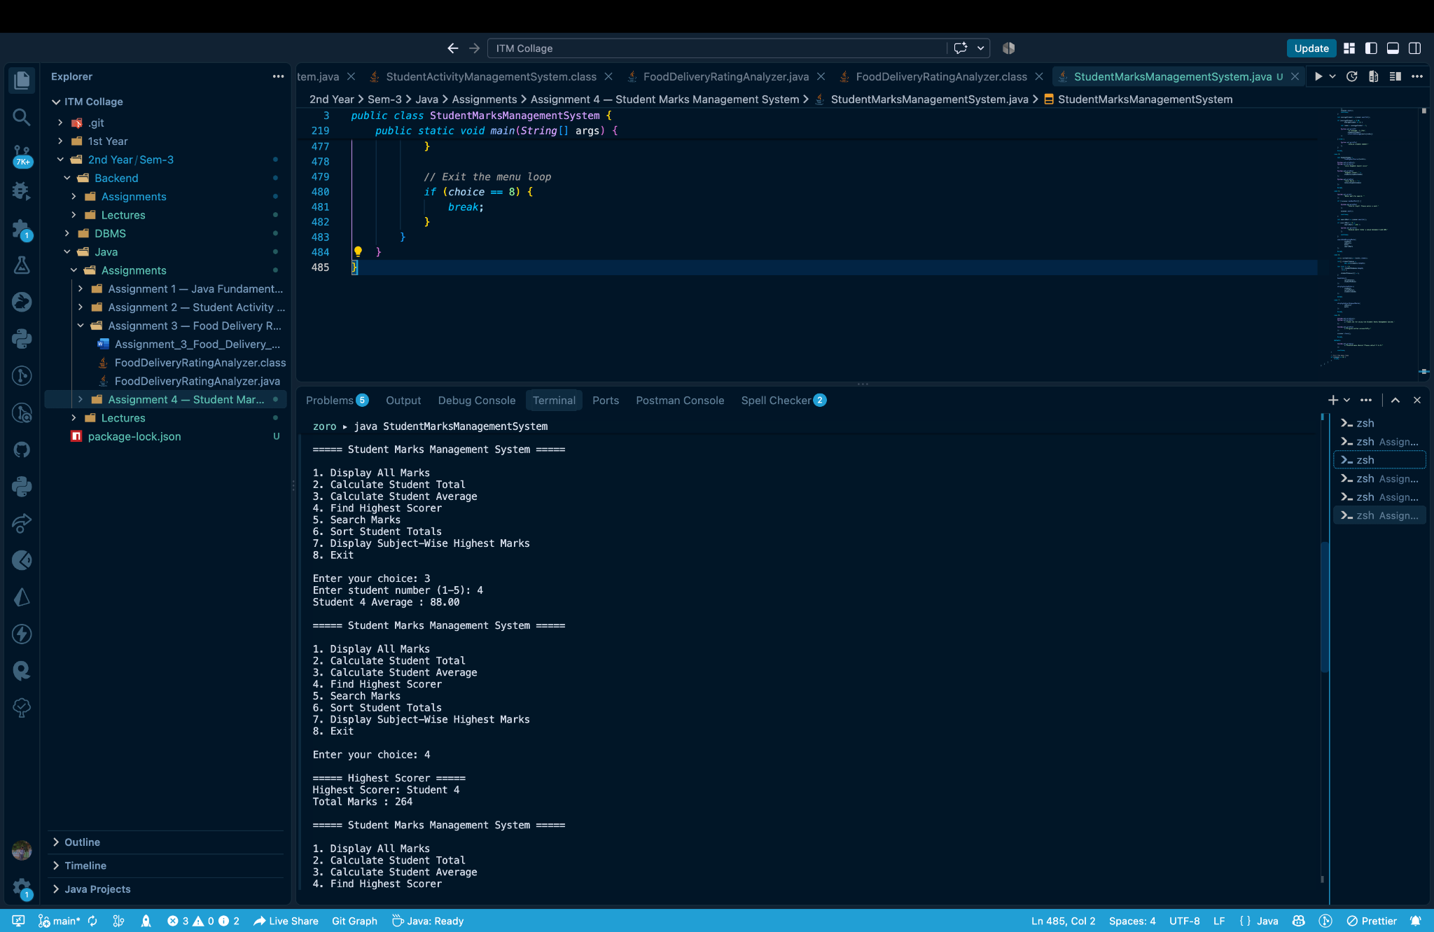
Figure 10.1 – Hotel Room Booking System execution
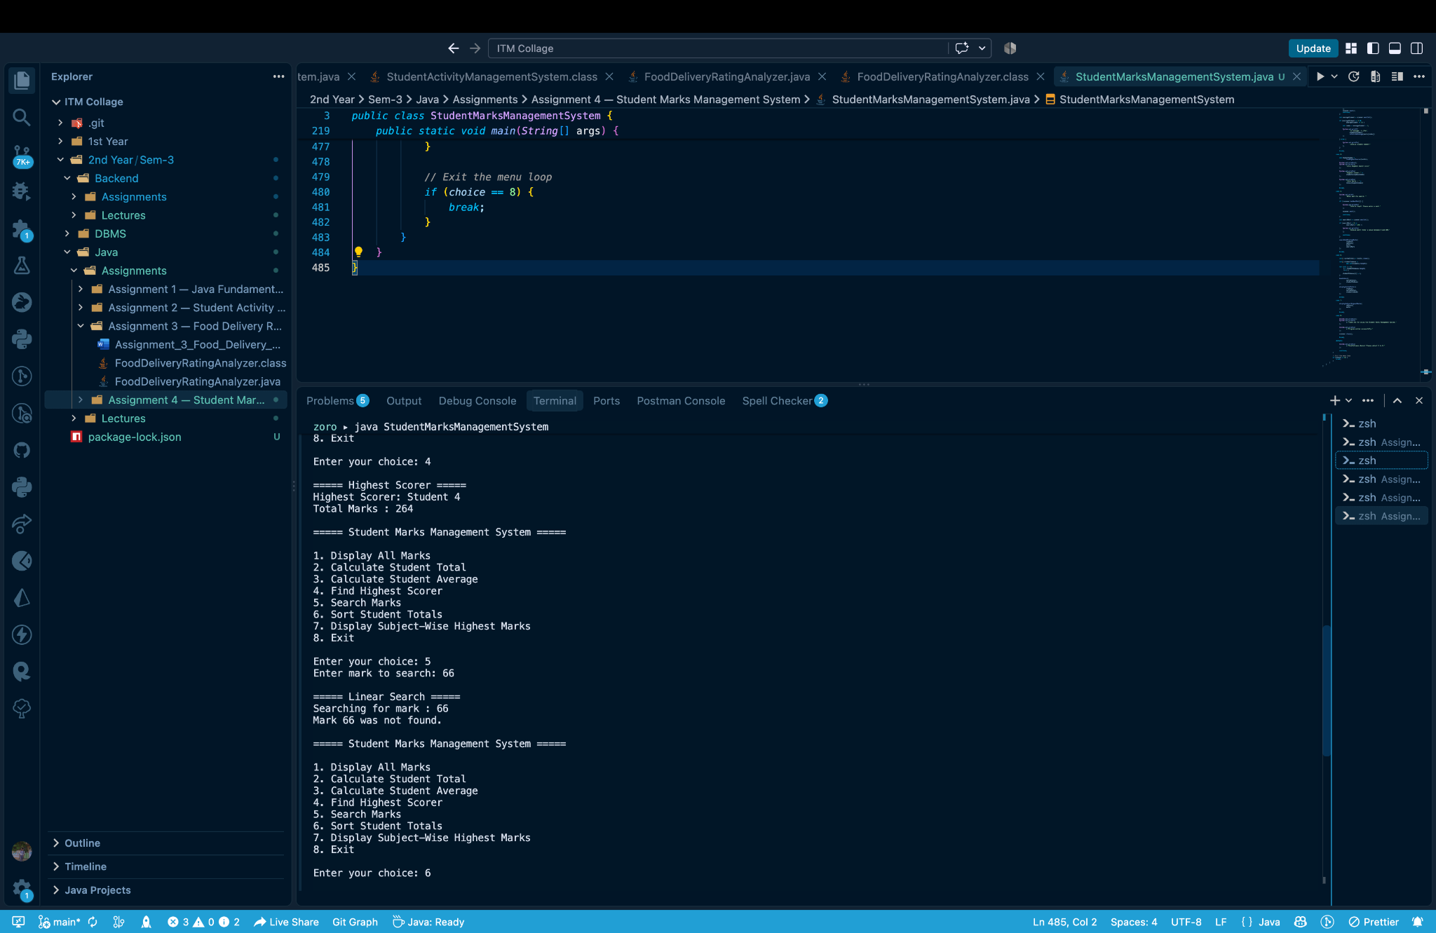
Figure 10.2 – Hotel Room Booking System execution
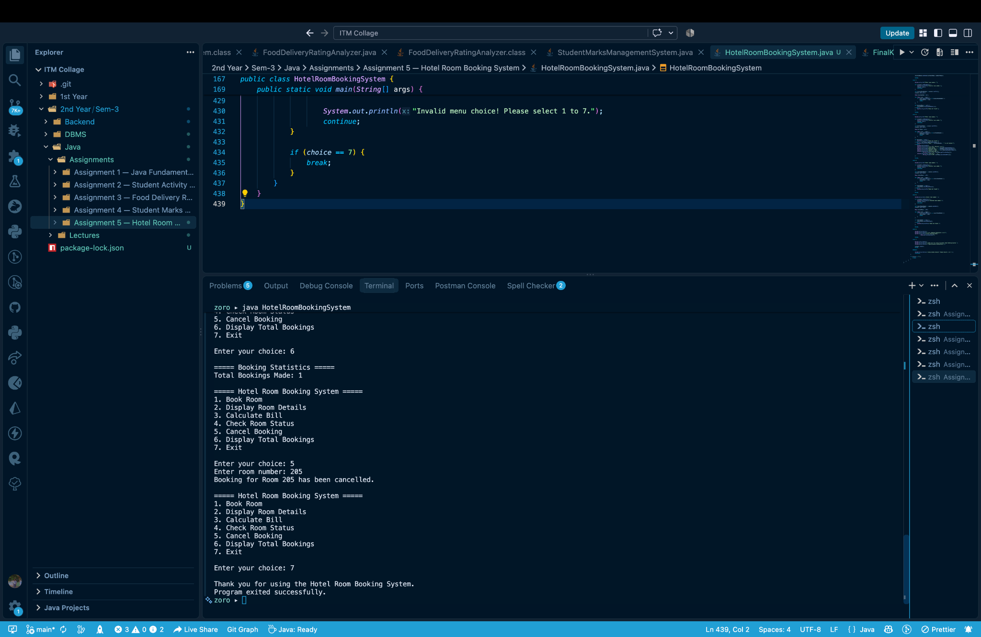
Figure 10.3 – Hotel Room Booking System execution
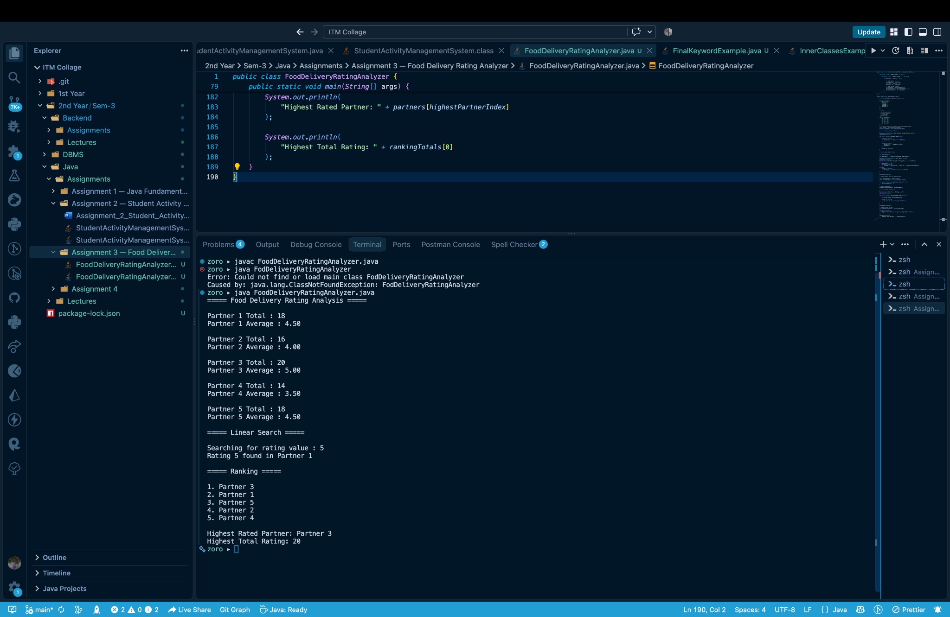
Figure 10.4 – Hotel Room Booking System execution

11. Requirement Verification
Requirement | Implementation
Room class | Implemented with room and customer-related attributes.
Private data members | All Room data fields are private.
Parameterized constructor | Used to initialize room number, type, and price.
this keyword | Used to distinguish instance fields from constructor/method parameters.
Getters and setters | Implemented for controlled access to room information.
Static booking counter | totalBookings tracks bookings across Room objects.
Booking operation | Stores customer details, days, status, and increments booking count.
Bill calculation | Number of Days × Price Per Day.
Display operation | Shows complete room and booking details.
Status operation | Reports Available/Booked state and customer when booked.
Cancel operation | Resets customer, days, and status.
Scanner input | Used for menu, room, customer, and stay-duration input.

12. Conclusion
The Hotel Room Booking System successfully applies core Object-Oriented Programming principles to a practical hotel-booking scenario. The implementation demonstrates classes, objects, constructors, encapsulation, the this keyword, static state, methods, user input, and menu-driven control flow. The tested execution confirms that rooms can be booked, inspected, billed, checked, counted, cancelled, and managed through a clear console interface.

